Week 5

Airline Server:

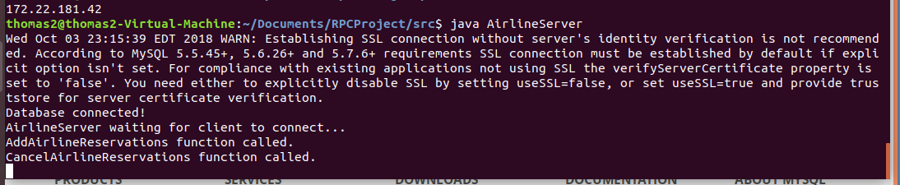

Client Server:

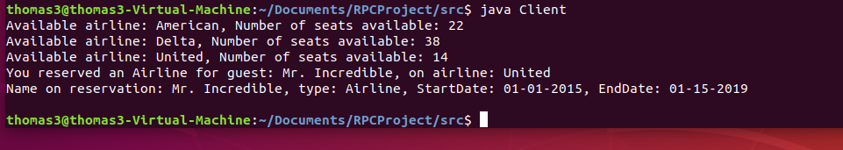

Database Server:

